CBSE CLUSTER XVIII ATHLETICS CHAMPIONSHIP –2026
Rules, Regulations & Technical Points
ELIGIBILITY
Age: The player should be within the particular age group on 31st December of the year of competition.
a) A student, who has failed twice in a particular class, shall no more be eligible to participate.
b) Incomplete Proforma in any respect is liable for disqualification of team.
c) A player should be under 14, 17 & 19 years of age on 31st Dec. 2026.
1. Under 14 years: Born on or after 01.01.2013
2. Under 17 years: Born on or after 01.01.2010
3. Under 19 years: Born on or after 01.01.2008
All the supporting papers verifying the age of the player, etc. in original, as per the CBSE Guidelines & Rules shall be carried personally by the Team Manager/Coach while reporting for the participation.

ATHLETICS
(BOYS‟ & GIRLS‟)
1. The meet shall be conducted according to the rules of Amateur Athletic Federation of India, with required
modifications if necessary.
2. Every school will be entitled to enter only one athlete in each event, except in relay races where a team of
maximum five athletes can be entered.
3. The various age categories and list of events in which competition will be held:
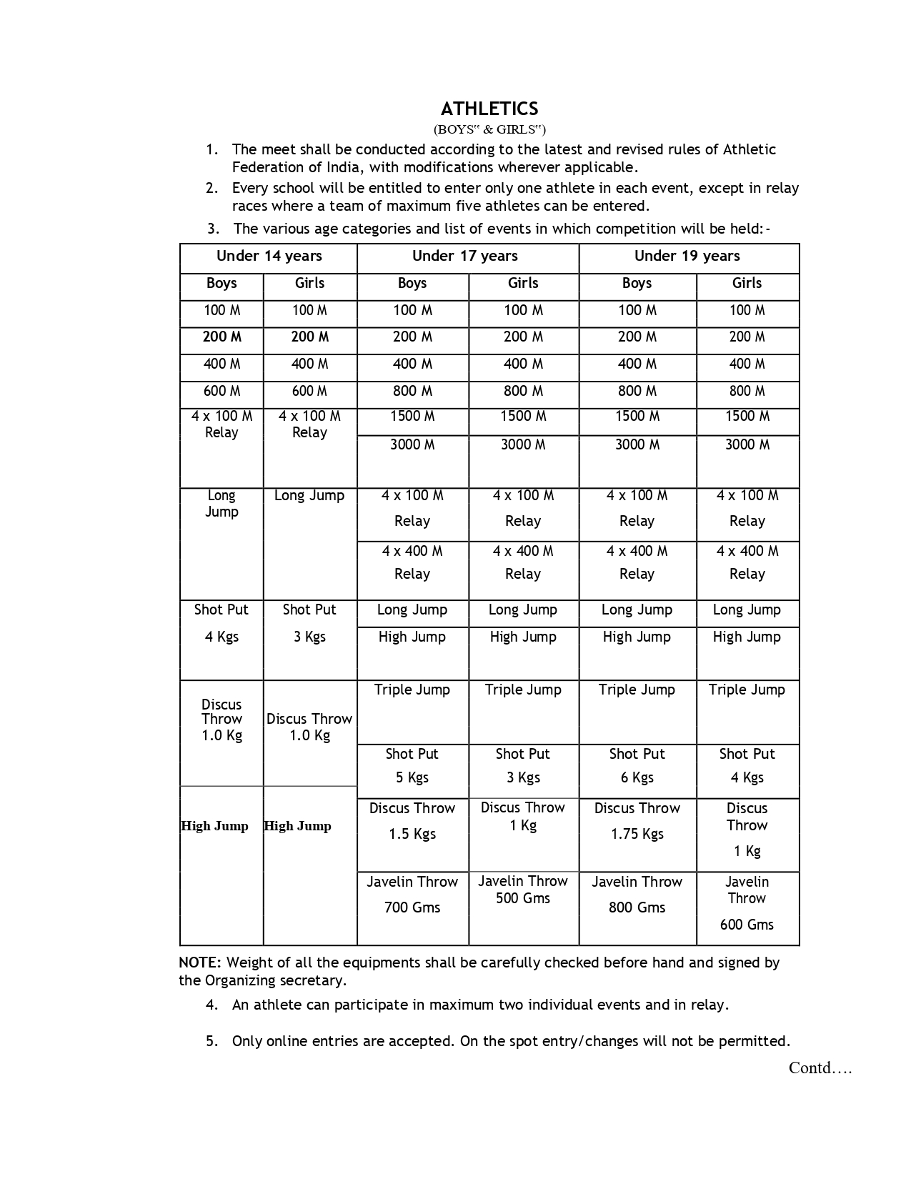

Note: - Weight of all the equipments shall be carefully checked before hand and signed by the Organizing secretary.
4. An athlete can participate in maximum two individual events and in relay.
5. Only online entries are accepted. On the spot entry/changes will not be permitted.
Contd….

6. The athletes winning first and second position holders at Cluster level shall qualify to take part in National level
Athletic Meet. In relay events, only the first position winning team from each category for boys and girls separately
will be allowed to participate in Nationals.

7. In a particular event, if the number of athletes is less than four; but they are from different Institutions/
Clusters, it may be conducted. The winners may be awarded the medals and the merit certificate, but, they
may not be awarded the points so as to be included for the Team Championship. However, their points will
be considered for individual championship.

8. In case of relays, all the five members of the team (if five names are given before the meet in the eligibility
Performa and all five have attended the meet) irrespective of who runs the finals, shall be awarded the
Medals and Certificates.

9. Immediately after the Cluster level meets, the Organizing School shall send the list of athletes qualified,
with their school name and complete postal address to the National Meet Organizing School through online form

10. All the Principals of such schools from where the Athletes have qualified to participate in the National meet
must inform their Athletes, indicating the venue and the dates of the National meet and plan their journey
(reservation etc.). They should also inform the Organizing School about their arrival and departure schedule.

11. In relays, only a single school team will be allowed to participate.

12. The Overall Championship separately in boys and girls sections in all the age groups may be decided. The
points shall be awarded according to the following system:-
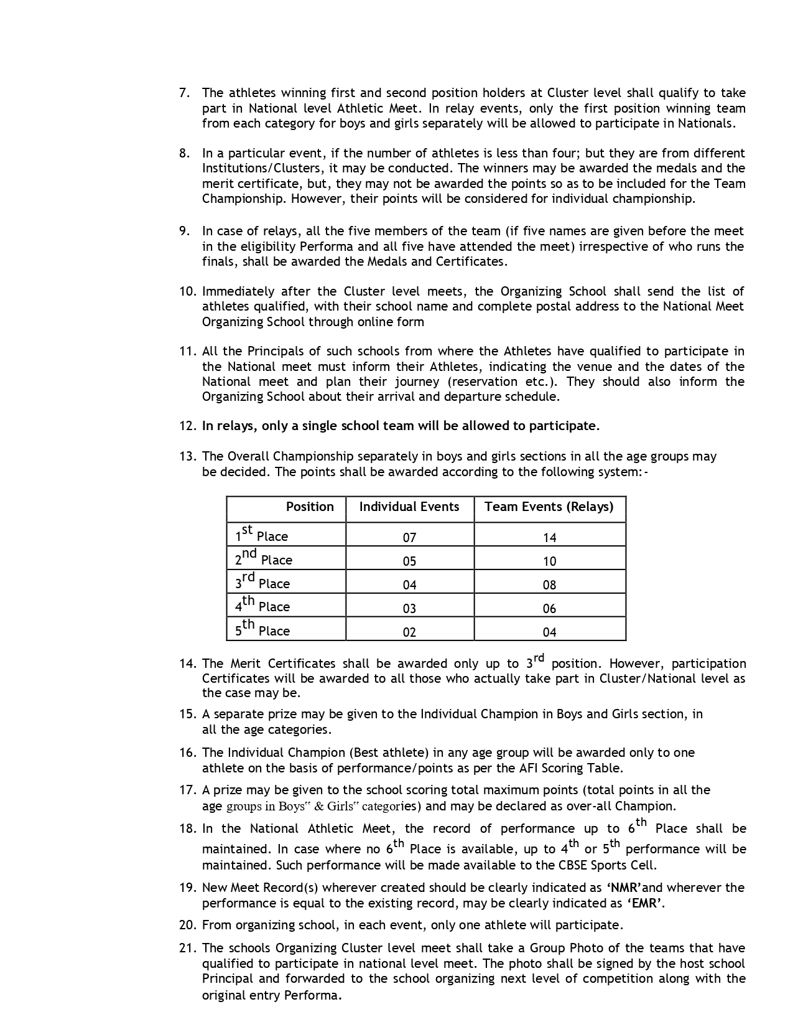

13. The Merit Certificates shall be awarded only up to 3rd position. However, participation Certificates will be
awarded to all those who actually take part in Cluster/National level as the case may be.

14. A separate prize may be given to the Individual Champion in Boys and Girls section, in all the age
categories.

15. The Individual Champion (Best athlete) in any age group will be awarded only to one athlete on the basis of
performance/points as per the AFI Scoring Table.

16. A prize may be given to the school scoring total maximum points (total points in all the age groups in Boys‟ &
Girls‟ categories) and may be declared as over-all Champion.

17. In the National Athletic Meet, the record of performance up to 6th Place shall be maintained. In case where no 6th
Place is available, up to 4th or 5th performance will be maintained. Such performance will be made available to the
CBSE Sports Cell.

18. New Meet Record(s) wherever created should be clearly indicated as ‘NMR’and wherever the performance is equal
to the existing record, may be clearly indicated as ‘EMR’.

19. From organizing school, in each event, only one athlete will participate.

20. The schools Organizing Cluster level meet shall take a Group Photo of the teams that have qualified to
participate in national level meet. The photo shall be signed by the host school Principal and forwarded to the
school organizing next level of competition along with the original entry Performa.

GENERAL INSTRUCTION REGARDING ATHLETICS CHAMPIONSHIP:
1. The entry forms, travel plan, student participation details and attested identity card format which are given
on the CBSE website www.cbseacademic.in or school’s website should be filled in capital letters and sent
immediately.
2. The participants with their Coaches and Managers must be in school campus by 8.00 pm every night during
their stay in our school.
3. The Organizing Committee has the right to change fixture, venue and time of the event.
4. Whatsoever the reason may be, late entry, spot entry and telephonic entry shall not be entertained. (Postal
delay will not be considered as an excuse).
5. Each school will send one Coach/Manager with team who will be responsible for the conduct of
participants. A female official must accompany the girl’s team.
6. The officials accompanying the team shall have a valid Identity Card issued by their school Principal.
7. No extra person without proper identity shall be permitted to stay inside the school premises and on
the playfield along with the team.

ALTERNATE CONTACT PERSON & MOBILE NOS.
1. Ms. Suman (Organising Secretary) – 9569453307
2. Mr. Bhupinder Singh (Co-ordinator Athletic Meet) -9888728518
3. Mr. Abhishek Kumar (Registration Checking) - 9646635150
4. Mr. Manoj Kumar (Transport) - 8288999019

********

